­

Adobe Summit 2017 Lab 3847:

Unleash your mobile app experience with developer customizations

Adobe Experience Manager Mobile

Introduction 4

Goal 4

Objectives 4

Module 1 – AEM & PhoneGap Developer Tools Introduction 5

Lesson 1 – PhoneGap Developer Tools 5

Overview 5

Objectives 5

Exercise 1 – Build and run the PhoneGap Developer app from source 5

Exercise 2 – Use PhoneGap Serve to Preview your mobile app 6

Exercise 3 – Debug your app with the Safari remote debugger 6

Exercise 4 – Make a change to the Mixology app source 7

Lesson 2 – AEM Basics 8

Overview 8

Objectives 8

Exercise 1 – Start your AEM Author and Publish instances 8

Exercise 1 – Sign in to AEM 9

Exercise 2 – Review the AEM Content Services solution 9

Exercise 3 – Publish content for use by the Mixology app 10

Outcome 11

Module 2 – Using AEM Content Services data in a mobile app 12

Lesson 1 – Consuming CaaS content from a hybrid app 12

Overview 12

Objectives 12

Exercise 1 – Set the server address from which the app will fetch its data 12

Exercise 2 – Write code to fetch drinks JSON data from the server 12

Exercise 3 – Write code to fetch Collections JSON data from the server 13

Exercise 4 – Write HTML for rendering a list of drink Collections 13

Outcome 14

Module 3 – Content Sync, articles to JSON for app use 15

Lesson 1 – Review and Reuse Web News Articles 15

Overview 15

Objectives 15

Exercise 1 – View We-Mix Site 15

Exercise 2 – Review existing News content in app 15

Exercise 3 – Stage and publish a content update 16

Exercise 4 – Refresh the app 18

Outcome 18

Lesson 2 – Create and configure an export handler for news article assets 18

Overview 18

Objectives 18

Exercise 1 – Create a custom export handler for news assets 18

Exercise 2 – Configure We.Mix’s export config to include the new asset exporter 18

Exercise 3 – Stage and publish another update to include the images 20

Exercise 4 – Refresh the app 20

Outcome 20

Bonus: Module 4 – Reuse Content Services data for web 21

Lesson 1 – Content Services component 21

Overview 21

Objectives 21

Exercise 1 – Open the We.Mix site for authoring 21

Exercise 2 – Wire up the Drink component to Content Services endpoint 22

Exercise 3 – Create a new Drink page 22

Outcome 24

Bonus: Module 5 – Customize App Dashboard 25

Lesson 1 – Extend the app dashboard with a custom tile 25

Overview 25

Objectives 25

Exercise 1 – Create a custom tile 25

Exercise 2 – Configure the WeMix dashboard to include the custom tile 25

Outcome 26

Summary 26

# Introduction

Adobe Experience Manager provides a complete toolset to rapidly build, manage, and deliver mobile apps that integrate with the Adobe Marketing Cloud. Leverage existing content from multiple sources including the easy-to-use authoring environment of AEM, as well as Content Services – soon to be released in the AEM 6.3 timeframe.

# Goal

Users have never expected more from their mobile apps. As a developer, learn how to maximize your investment in Adobe Experience Manager, and create mobile-optimized components. Get ready to deliver engaging and optimized experiences that will continue to surprise and delight your users!

# Objectives

* Introduce the PhoneGap hybrid app developer workflow
* Consume Content Services data from a hybrid app
* Use Content Sync to export web content for offline app use
* Reuse Content Services data in an AEM Site
* Extend AEM Mobile with a custom dashboard tile

# Module 1 – AEM & PhoneGap Developer Tools Introduction

This module will provide a general introduction to the PhoneGap developer workflow and Adobe Experience Manager.

## Lesson 1 – PhoneGap Developer Tools

### Overview

PhoneGap developer tools provide a streamlined workflow for developing mobile apps across multiple platforms, on both physical and simulated device hardware.

### Objectives

* Use the PhoneGap command line interface (CLI) to build and run the PhoneGap Developer App from source
* Use the PhoneGap CLI to preview our Mixology app in the iOS Simulator
* Make a change to the source of the Mixology app, and see that change reflected in the iOS Simulator immediately

### Exercise 1 – Build and run the PhoneGap Developer app from source

1. Open the Simulator application from the system dock:

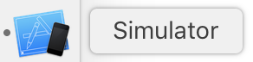

1. Open the Terminal application from the system dock:

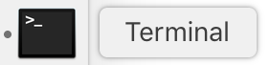

1. From the Terminal’s command line, navigate to ~/Desktop/AEMM-Labs/L3847/resources/phonegap-app-dev. This can be accomplished with the following command:

cd ~/Desktop/AEMM-Labs/L3847/resources/phonegap-app-dev

1. Using the PhoneGap command line interface (CLI), build and run the PhoneGap Dev app with the following command:

phonegap emulate ios --target "iPhone-7, 10.2" -d

1. After a few minutes (can take longer depending on the machine), the iPhone 7 simulator will start up, and the PhoneGap Developer app will be installed onto it. The simulator should now show the following screen:

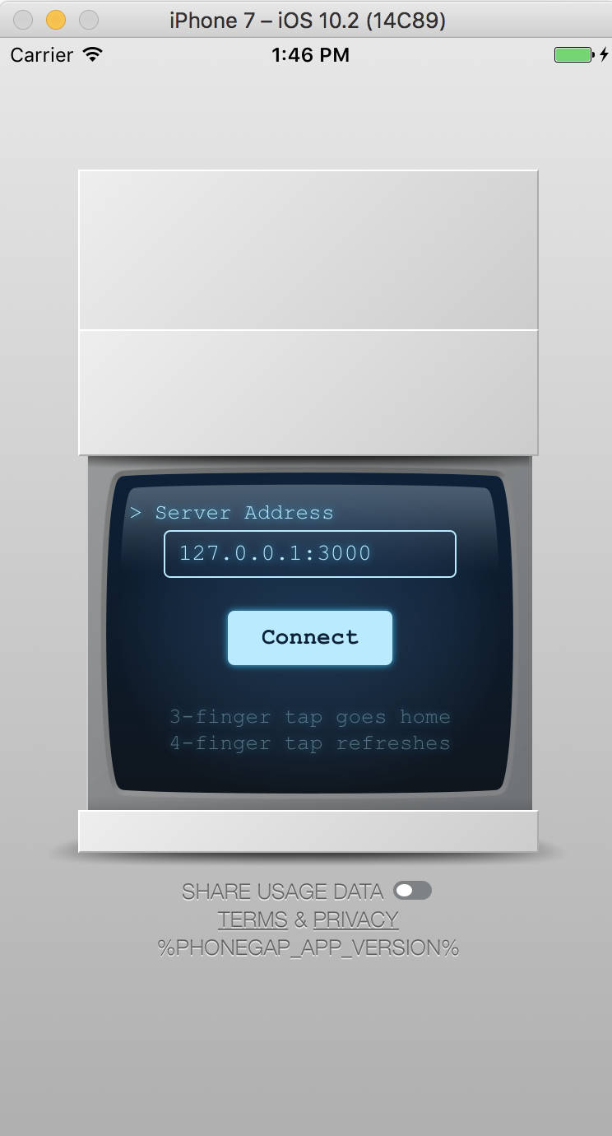

### Exercise 2 – Use PhoneGap Serve to Preview your mobile app

1. Using the Terminal, navigate to the lab application’s source code:

cd ~/Desktop/AEMM-Labs/L3847/resources/mixology/hybrid

1. Use the PhoneGap CLI to start a local web server that will enable us to preview our app instantly during development:

phonegap serve

1. Back in the iPhone 7 Simulator, tap the light blue “Connect” button to connect to the web server we just started, and begin previewing the Mixology app. Once complete, your iPhone Simulator will look as follows:

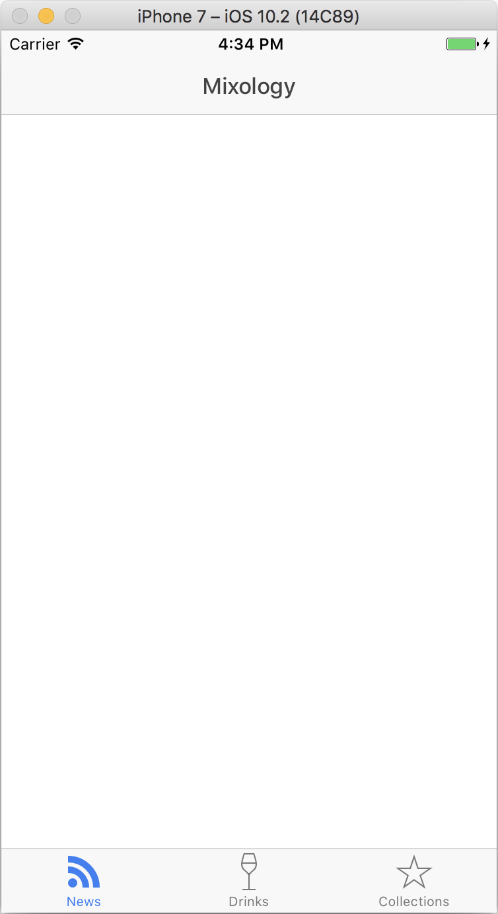

### Exercise 3 – Debug your app with the Safari remote debugger

1. Open the Safari web browser, either from the dock or via the Finder app > Applications > Safari
2. From the menu bar, open the Develop menu, then hover your mouse over “Simulator”
3. From the sub menu which appears, select “Mixology” (or, "index.html"):

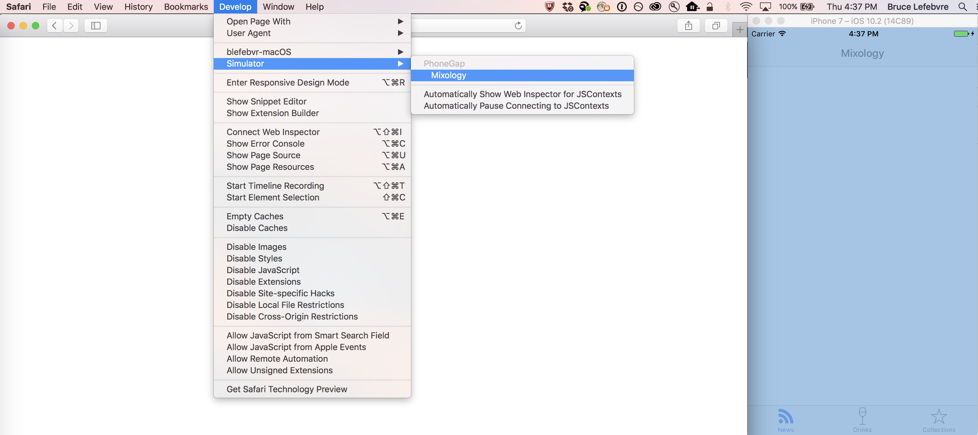

1. In the window which appears (titled "Web Inspector – Simulator – PhoneGap – index.html"), open the Console tab:

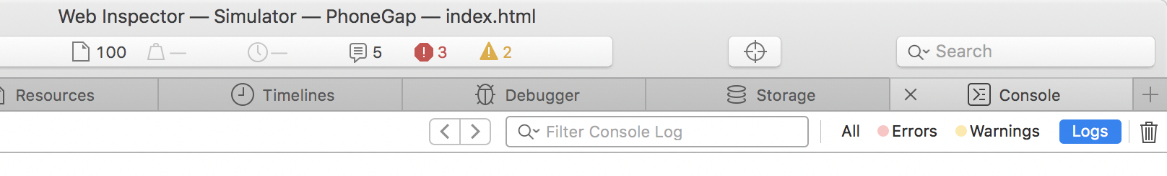

The Mixology app is very verbose in its log output, so this will be a good place to look first if something goes wrong. Additionally, you can use the Resources tab of this window to set breakpoints in your code.

### Exercise 4 – Make a change to the Mixology app source

1. Open the Brackets app from the OS X Dock. It’s icon looks like this:



1. From the Brackets menu, select File > Open Folder…
2. Navigate to the app’s source code, located at ~/Desktop/AEMM-Labs/L3847/resources/mixology/hybrid, and press Open:

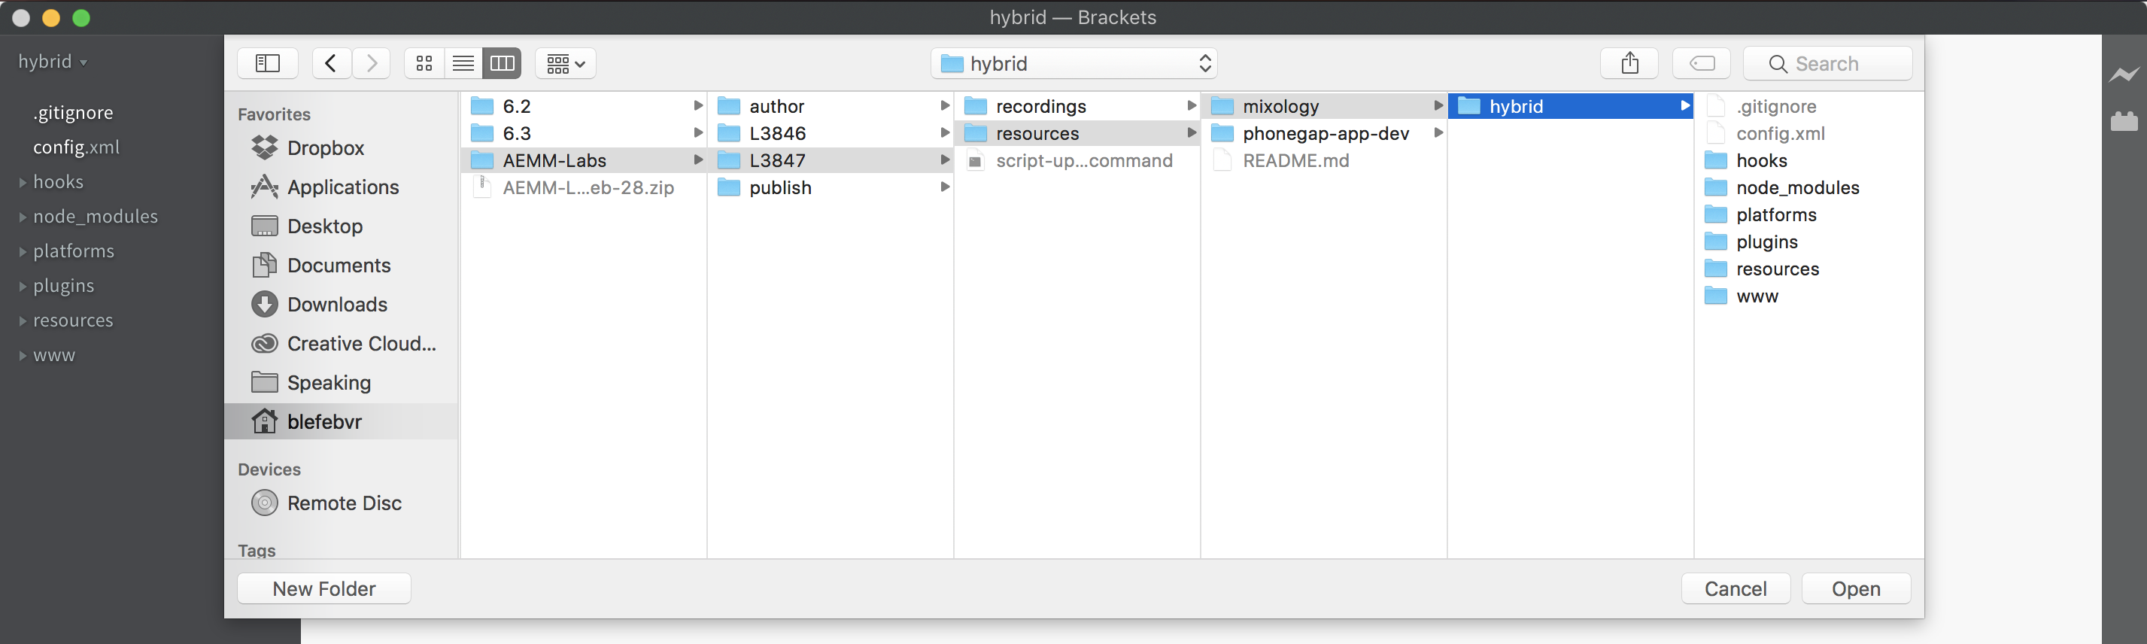

1. From the file browser on the left, expand the www directory, then templates
2. Click ‘tab-news.html’ to open it in the editor
3. In line 1, change the view-title attribute value from ‘Mixology’ to something unique, such as your company’s name.
4. Save the file, either by pressing command + S, or File > Save

Switch back to the iPhone Simulator. Your app will immediately update, with the view-title you set placed in the header of the ‘News’ tab:

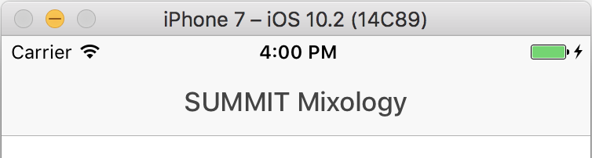

Tip: position the Brackets window next to the iPhone Simulator so you can see your changes immediately in the simulator.

## Lesson 2 – AEM Basics

### Overview

Adobe® Experience Manager helps you organize, create, and manage the delivery of creative assets and other content across your digital marketing channels, including web, email, communities, and video—and in our case for this lab, mobile apps. Marketers can quickly update mobile apps with engaging content without requiring app rebuilds and resubmission.

### Objectives

* Learn how to run AEM, and sign in
* Explore the AEM Content Services solution

### Exercise 1 – Start your AEM Author and Publish instances

1. On the desktop of your machine, locate and open the directory named ‘AEMM-Labs’
2. Open the ‘author’ folder
3. Double-click ‘aem-author-4502.jar’ to run the AEM 6.3 (beta) Author instance



1. Navigate up one directory to ‘AEMM-Labs’
2. Open the ‘publish’ folder
3. Double-click ‘aem-publish-4503.jar’ to run the AEM 6.3 (beta) Publish instance

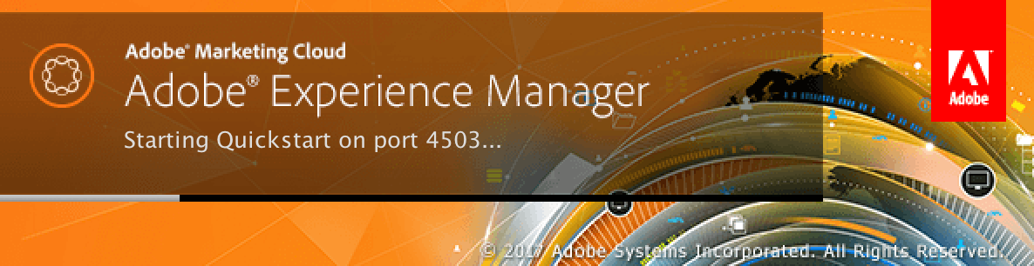

Once your AEM Author instance has started, the following page will be opened in the browser automatically (on port :4502):

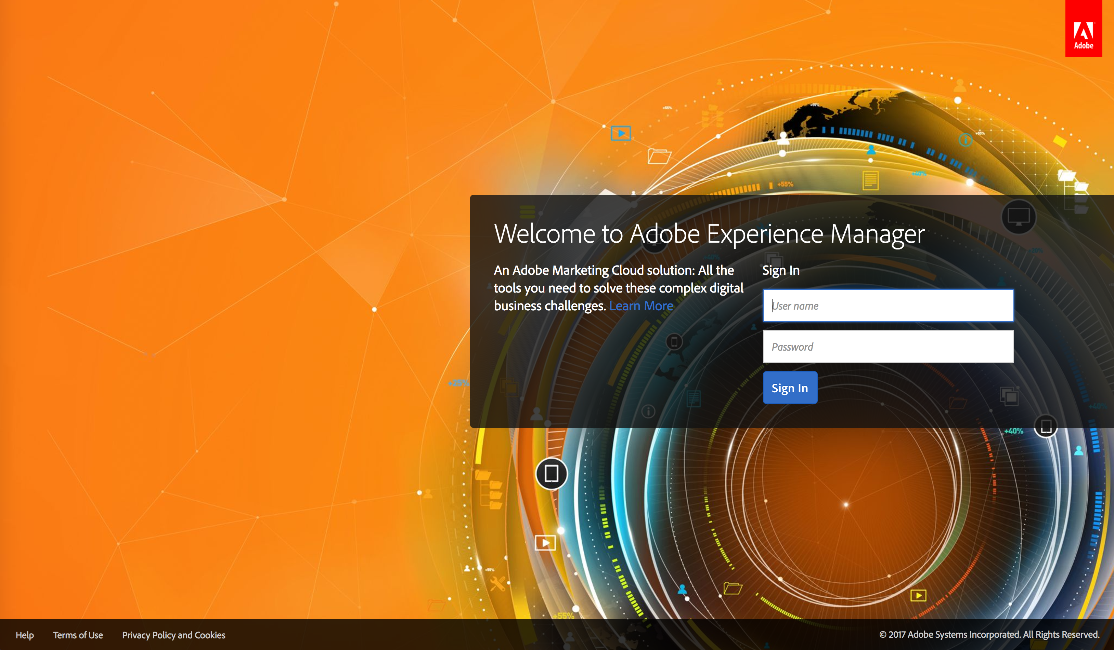

Once your AEM Publish instance has started, the following page will be opened in the browser automatically (on port :4503):



It should only take a couple of minutes to start up both instances.

### Exercise 1 – Sign in to AEM

1. Navigate to the AEM Author login in a browser (<http://localhost:4502/>)
2. Enter the user name ‘admin’
3. Enter the password ‘admin’
4. Click ‘**Sign In’**

### Exercise 2 – Review the AEM Content Services solution

1. The AEM Navigation shade will appear initially after logging in to AEM
2. The majority of our time spent in AEM will take place in the Content Services console. Select the Content Services item to open it’s submenu: 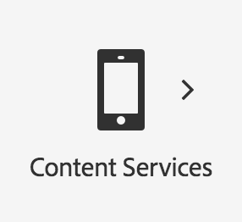
3. Select the “Spaces” entry 
4. Explore the “Drinks” space. Select the space name (“Drinks”) to view it’s associated entities
5. Select “Drink Recipes” to open the drink recipes group
6. Edit a drink of your choice by first selecting the it’s thumbnail image.
   1. Then, select “Edit” from the buttons which appear in the header actionbar
7. From this screen you can view and manage the properties of this entity, which are displayed based on how it’s model has been configured:

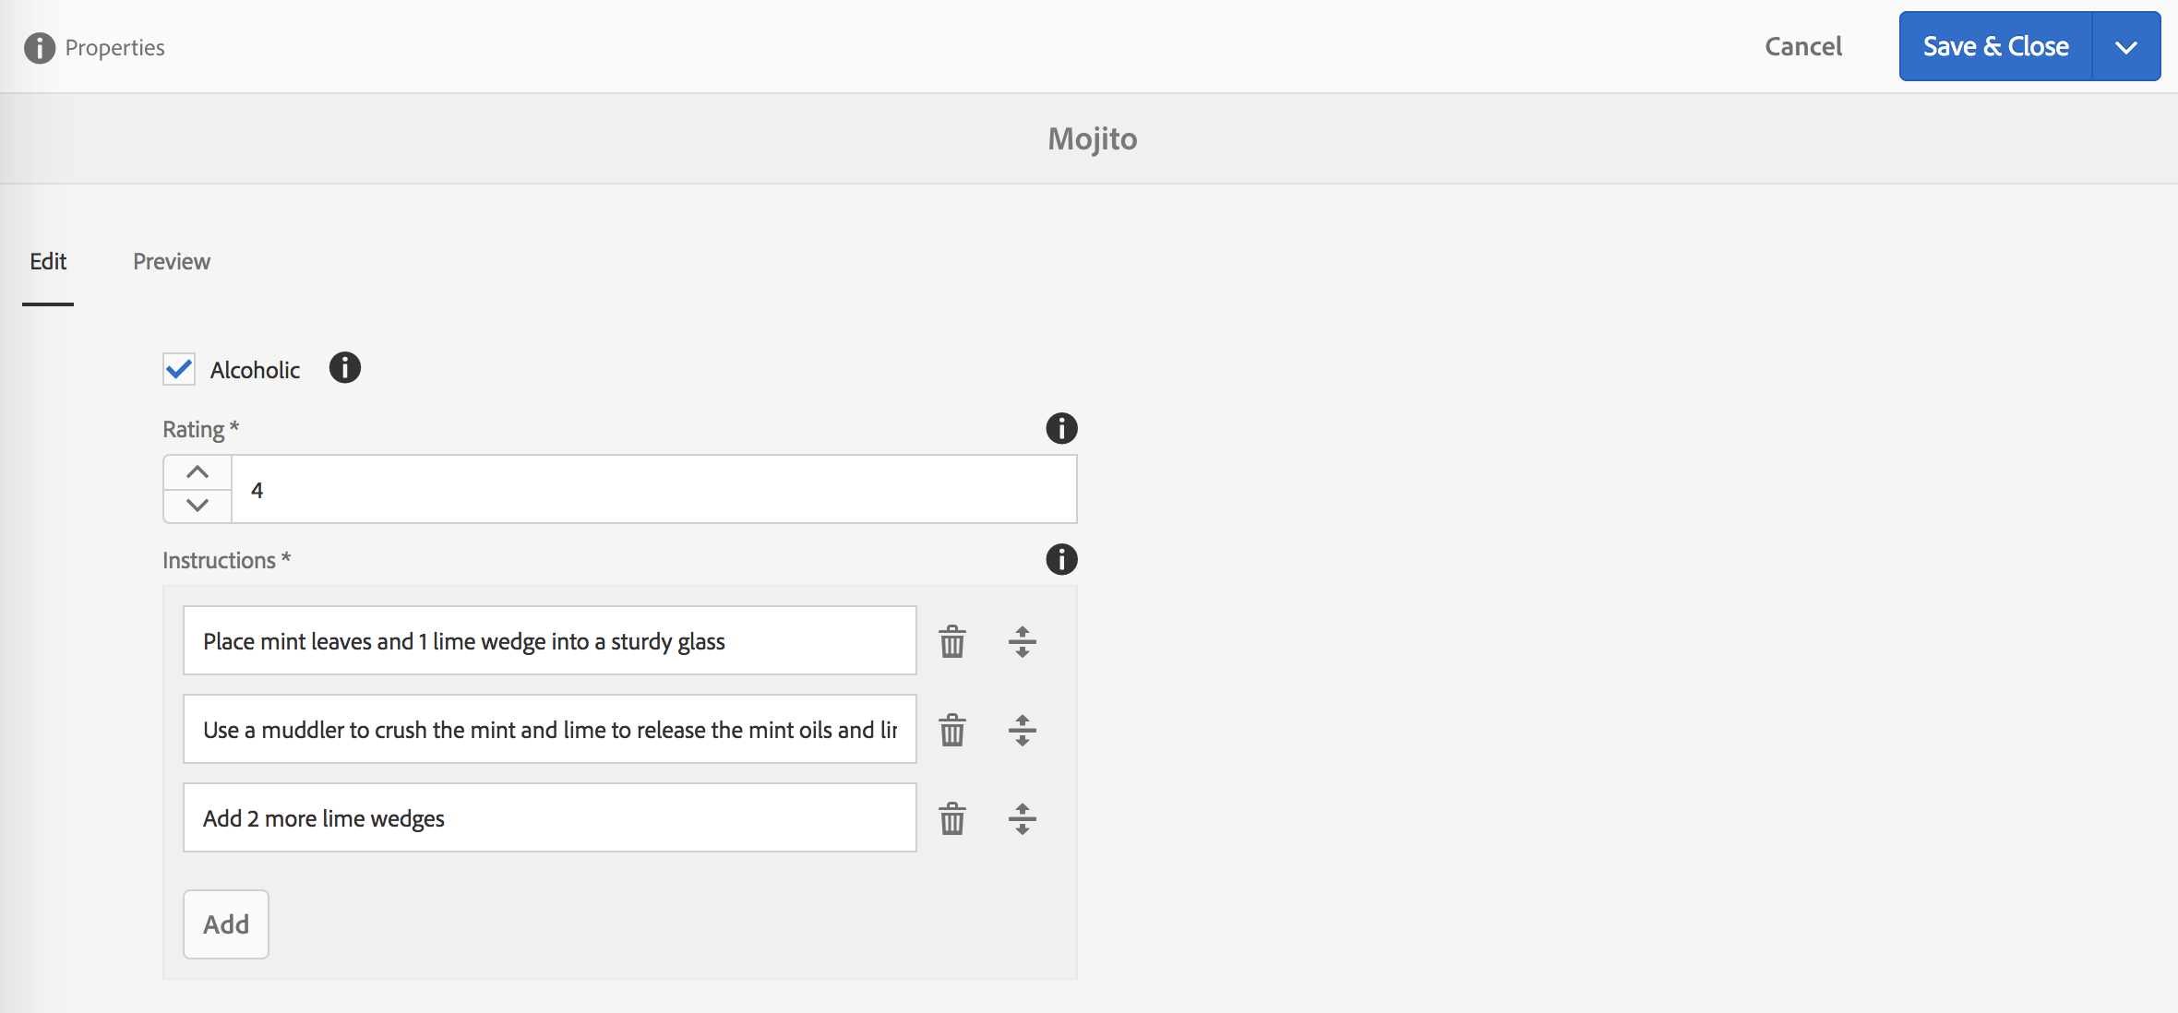

1. Select the “Preview” tab to view how this entity’s JSON will render. If you made edits, save to preview latest 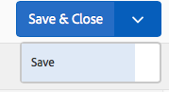
2. Increase the “Depth” count to include more data (in this case: further detail on the ingredients associated with this recipe):

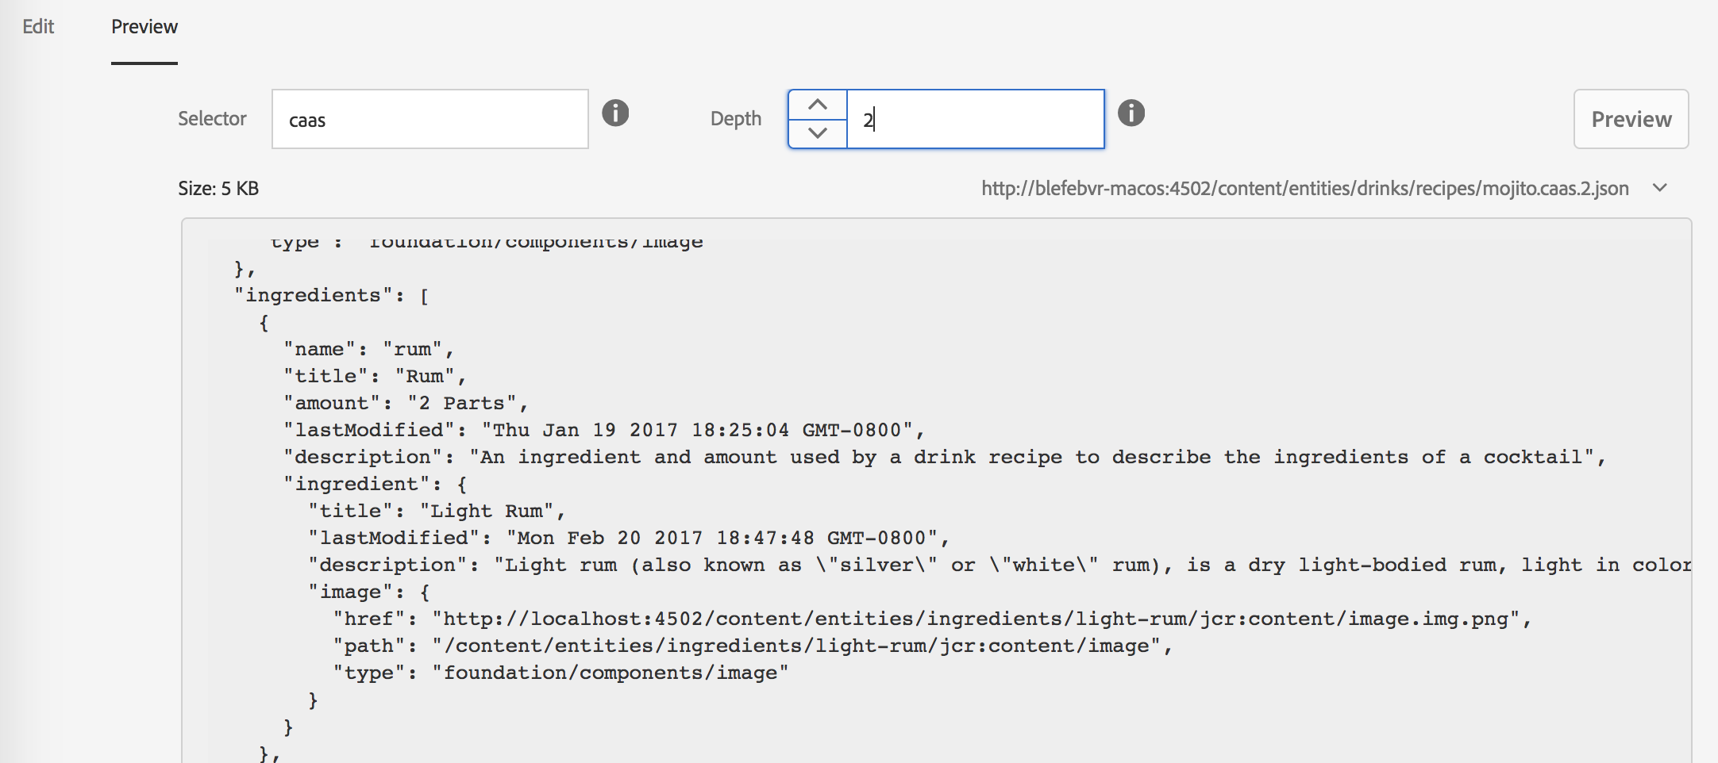

### Exercise 3 – Publish content for use by the Mixology app

Like AEM Sites content, Content Services data will not be made available on a publish instance unless that content is explicitly published. Take the following steps to publish both the “Drinks” and “Drink Ingredients” entities:

1. The first set of entities we are going to publish are found in the space named Drinks, and contains our Mixology app’s recipe content
   1. You can access this content directly in the browser on your local Author instance: <http://localhost:4502/content/entities/drinks.caas.1.json>
   2. Note, however, that this content is not yet available on Publish: <http://localhost:4503/content/entities/drinks.caas.1.json>
2. Navigate to the Content Services Spaces console (<http://localhost:4502/libs/mobileapps/caas/admin/content/spaces.html/content/entities>)
3. Select the Drinks entity by clicking once on its thumbnail image. It should now appear selected:

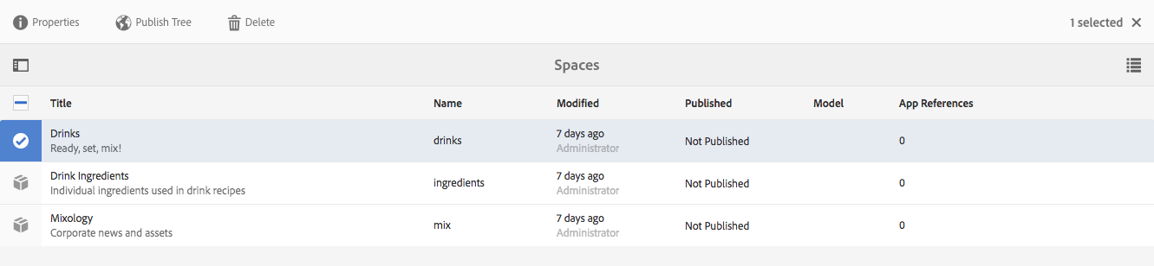

1. From the actionbar, select “Publish Tree”
2. Verify that the drinks JSON content is now available on publish: <http://localhost:4503/content/entities/drinks.caas.1.json>
3. De-select the Drinks entity
4. Select the “Drink Ingredients” entity by clicking once on its thumbnail image
   1. Modeling the Drink Ingredients in its own data structure allows us to maximize reuse between recipes
5. From the actionbar, select “Publish Tree”
6. Verify that the drink ingredients JSON content is now available on publish: <http://localhost:4503/content/entities/ingredients.caas.1.json>

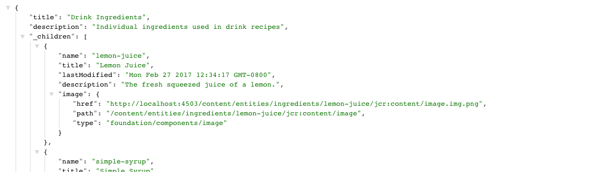

### Outcome

Congratulations! You are now familiar with the basics of the PhoneGap Developer tools, and have a streamlined workflow at your disposal. You also know where to go to find Content Services data, how to make basic changes to entities, and the workflow for moving those entities to a publish instance.

# Module 2 – Using AEM Content Services data in a mobile app

This module will focus on bringing the Content Services data from AEM, into our Mixology app. We’ll start with the data for the Drinks tab, then bring in the data for the Collections tab.

## Lesson 1 – Consuming CaaS content from a hybrid app

### Overview

Our hybrid app is being previewed in the PhoneGap developer app, which means we can see our code changes reflected immediately across any devices and simulators that we’ve connected to the phonegap serve local webserver. In this lesson we’ll wire the app up to AEM to fetch the Content Services data via an AJAX request.

### Objectives

* Use JavaScript to connect our app to the Content Services endpoints that are available in our local AEM instance

### Exercise 1 – Set the server address from which the app will fetch its data

1. Navigate to the Drinks tab in the iPhone Simulator. It should look as follows:

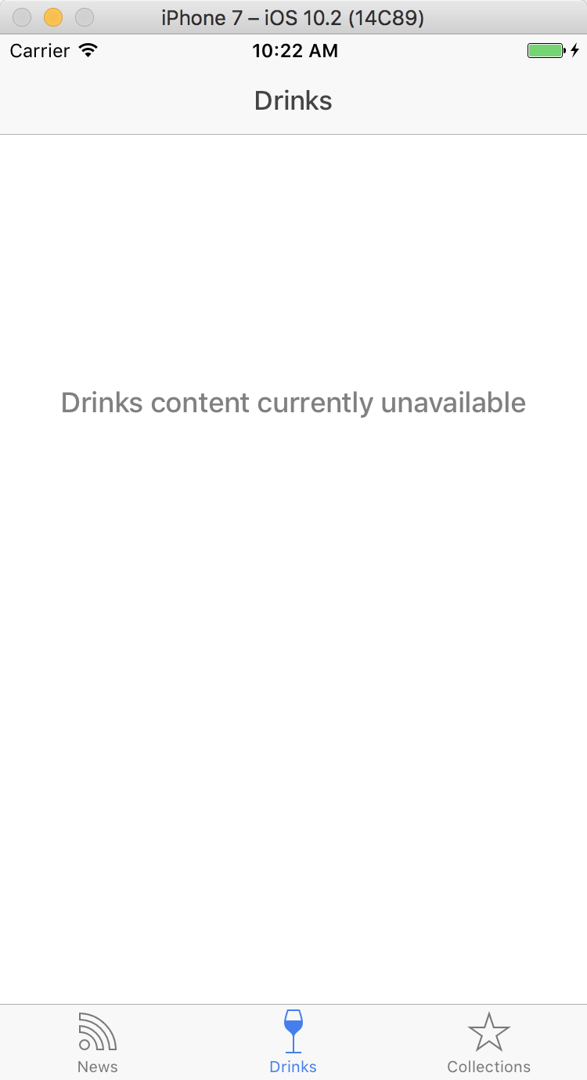

1. Using Brackets, locate and open the app’s configuration file (from the hybrid directory, www/js/services/config.js)
2. Locate the apiURL property on line 12
3. Replace null with the protocol, hostname and port the app will use to fetch it's data. In a real scenario, this would be the IP/hostname of the server
   1. Use 'http://localhost:4503' (including the quotes) to point to your local AEM publish instance
   2. Line 12 should now look as follows: apiURL: 'http://localhost:4503',
4. Save your changes to config.js

### Exercise 2 – Write code to fetch drinks JSON data from the server

1. Using Brackets, open the Drinks service (from the hybrid directory, www/js/services/drinks.js)
2. Locate the reject(..) function call on line 13
3. Replace line 13 with the $http call below:

|  |
| --- |
| $http  .get(config.apiURL + config.drinkRecipesJSON)  .then(function success(response) {  if (typeof response.data !== "object") {  reject("Error: no data. " + JSON.stringify(response));  }  else {  resolve(response.data);  }  }, function error(response) {  reject("Error: " + JSON.stringify(response));  }); |

1. Save the file.
2. Your iPhone Simulator will refresh automatically, and should now show a list of drinks – matching the Drinks content in AEM Content Services (you may need to switch to the Drinks tab):

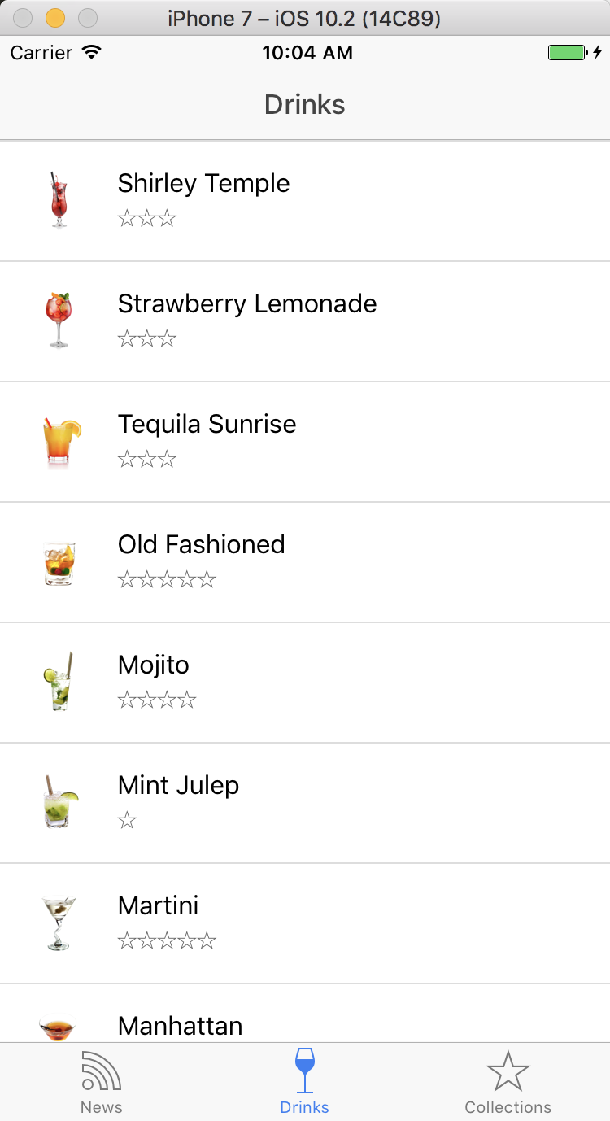

1. Try tapping one of the drinks to view details about its recipe.

### Exercise 3 – Write code to fetch Collections JSON data from the server

1. Navigate to the Collections tab in the iOS Simulator. It should display a message indicating "Collections content currently unavailable"
2. Using Brackets, open the Collections service (from the hybrid directory, www/js/services/collections.js)
3. Replace line 12 with the $http call below:
   1. Note the difference from fetching Drinks content: config.collectionsJSON is used instead of config.drinkRecipesJSON.

|  |
| --- |
| $http  .get(config.apiURL + config.collectionsJSON)  .then(function success(response) {  if (typeof response.data !== "object") {  reject("Error: no data. " + JSON.stringify(response));  }  else {  resolve(response.data);  }  }, function error(response) {  reject("Error: " + JSON.stringify(response));  }); |

1. Save collections.js
2. At this point the Simulator will refresh, but the Collections tab will be empty. We need to build out the HTML content that will render each Collection item.

### Exercise 4 – Write HTML for rendering a list of drink Collections

1. Using Brackets, open the Collections tab template (from the hybrid directory, www/templates/tab-collections.html)
2. On line 15, immediately following the comment, include the following HTML to render a list of collections:

|  |
| --- |
| <ion-list>  <ion-item ng-repeat="collection in collections" type="item-text-wrap" href="#/tab/collections/{{collection.name}}">  <h2>  {{collection.title}}  </h2>  <p>  {{collection.description}}  </p>  </ion-item>  </ion-list> |

1. Note how the collection title will be placed into a header element, while the description will be included beneath
   1. Additionally, the ion-item 's href points to the collections route, with the collection name provided as a state parameter
   2. To view the data being used to render this list of collections, navigate to the following URL:

<http://localhost:4503/content/entities/drinks/collections.caas.1.json>

1. The collections tab of the app should now look as follows. Try selecting a collection, viewing the drinks associated with it, and navigating to an individual drink recipe. Note how you are directed to the Drinks tab when selecting a drink; meaning no content in the app is unnecessarily duplicated.

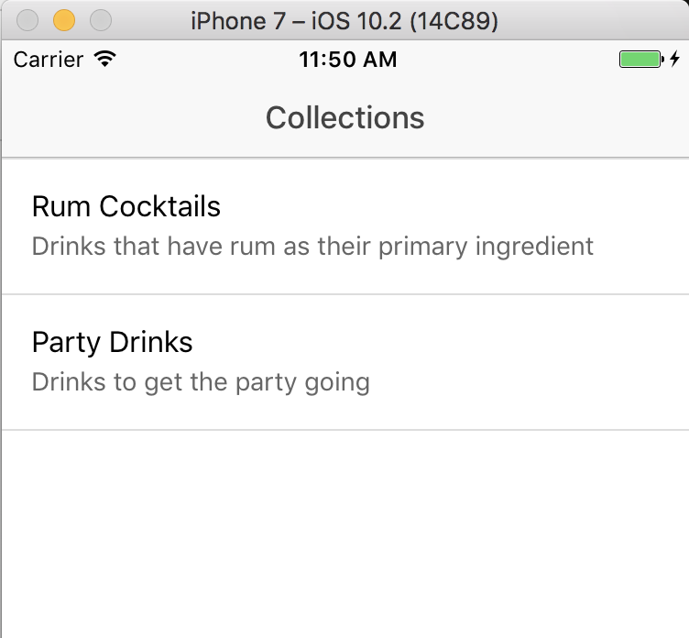

### Outcome

Congratulations! You have now wired up both the Drinks tab and the Collections tab of the app to pull content from AEM Content Services. Both tabs are fetching both the JSON data and associated images from the server each time they are needed, so this content will not be available offline. Assets included are shared throughout all channels via Digital Asset Management (DAM).

Note that you can "pull to refresh" in each tab of the app, so try changing a piece of content on AEM, publishing it, and observe how it changes immediately in the app.

# Module 3 – Content Sync, articles to JSON for app use

This module will provide a general introduction to ContentSync for content export and how it can be used to pull offline content and updates into a mobile app.

## Lesson 1 – Review and Reuse Web News Articles

### Overview

WeMix has a multi-channel presence and we would like to reuse some of the web content in the app.

### Objectives

* Review site content
* Stage a content update
* Publish a content update
* Update the app

### Exercise 1 – View We-Mix Site

1. Open a new browser window or tab to <http://localhost:4502/content/we-mix/en.html>
2. Click on **News** from the navigation menu



1. Click on the first news article **PUCKER UP FOR OUR BEST SOUR COCKTAILS.**



1. Review the new article. This is a sample news article we would like to reuse in our app.

We could choose to export and reuse web content as HTML via ContentSync however we will be exporting and reusing the content as JSON and assets using both ContentSync and CaaS

### Exercise 2 – Review existing News content in app

1. Switch to or relaunch the WeMix Hybird app in the iOS Simulator
2. Click on the News icon in the app tab bar 
3. Pull to refresh and note there is no content available yet

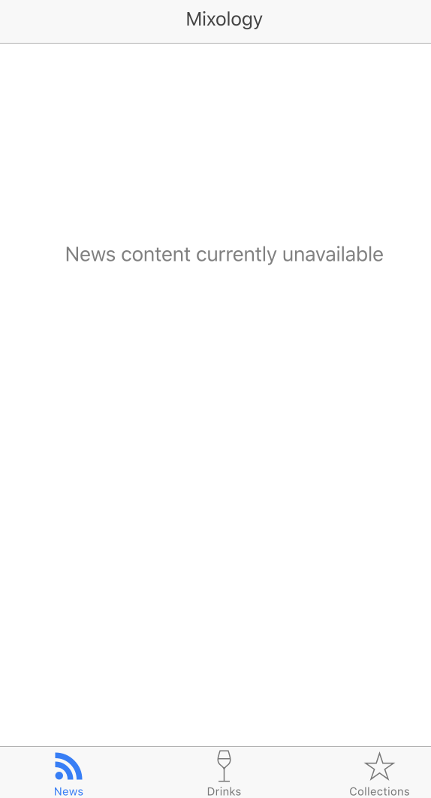

### Exercise 3 – Stage and publish a content update

1. Open a new browser window or tab to AEM Home page <http://localhost:4502/aem/start.html>
2. Click on **Content Services** 
3. Click on **Apps** 
4. Click on **We.Mix** 

This opens the We.Mix’s app dashboard that enables managing app. We will use the Manage Content Packages tile to stage and publish app updates of News Articles.  
An initial ContentSync Export Configuration has been created to pull out the News Articles from the We.Mix website as JSON

1. Click on the **English** Content Package from **Manage Content Packages** tile to manage content updates.

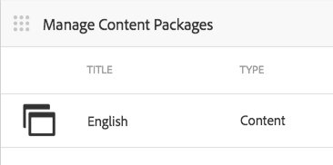

Note that no updates have staged yet.

1. Click the Stage icon 
2. Create an update, setting a title and description.

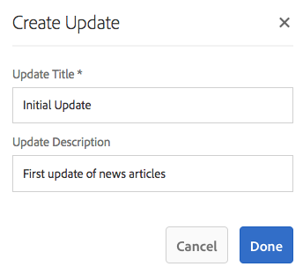

1. Click Done to complete the update.   
   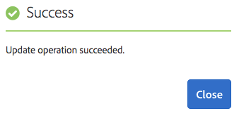  
   Note the new update listed however it has not yet been published.
2. Click Publish to publish the update and make it available to running apps  .

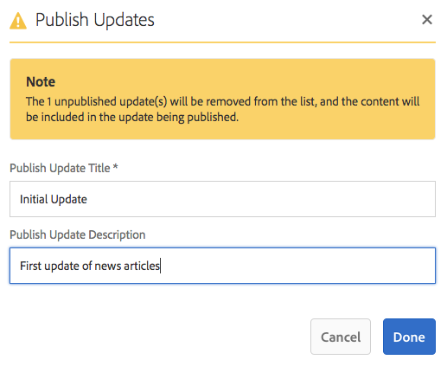  
You can rename the updates for publishing and click **Done** to complete  
   
You can confirm updates were published and are available on publish using;  
<http://localhost:4503/content/mobileapps/we-mix/content/jcr:content/exportConfigs/newsExportConfig.pge-updates.json>

You should see JSON indicating "updates": true

1. **[Optional]** Clickthe download update zip icon and inspect its contents to see what the app would be receiving 

### Exercise 4 – Refresh the app

1. Switch to or relaunch the Mixology app in the iOS Simulator
2. Click on the News icon in the app tab bar 
3. Pull to refresh  
   Note that content has been loaded however images are missing!
4. Click the first article **Pucker Up For Our Best Sour Cocktails**Note that the article text is loaded however its images are also missing!

The initial ContentSync Export Configuration was configured to only export the article metadata as JSON.  
In order to export images, we must reuse/create a ContentSync export handler and configure it into our app.

### Outcome

Congratulations! You have staged a content update that is now available to all instances of the app.

## Lesson 2 – Create and configure an export handler for news article assets

### Overview

Apps may require additional content and that content is needed for an offline experience. ContentSync facilitates content export and can deliver delta updates to the app which can be stored for offline experiences.

### Objectives

* Create/Use a custom ContentSync export handler
* Configure app content export to use the new handler
* Repeat the stage and publish
* Update the app with the new content

### Exercise 1 – Create a custom export handler for news assets

A custom export handler has been created for you and can be seen at   
~/Desktop/AEMM-Labs/L3847/resources/java-src  
It has already been built and installed to AEM

### Exercise 2 – Configure We.Mix’s export config to include the new asset exporter

1. Open CRXDE and navigate to the export config at */content/mobileapps/we-mix/content/jcr:content/exportConfigs/newsExportConfig*  
   <http://localhost:4502/crx/de/index.jsp#/content/mobileapps/we-mix/content/jcr%3Acontent/exportConfigs/newsExportConfig>
2. Right click on the **newsExportConfig** and click thru to **Create…** > **Create Node…**

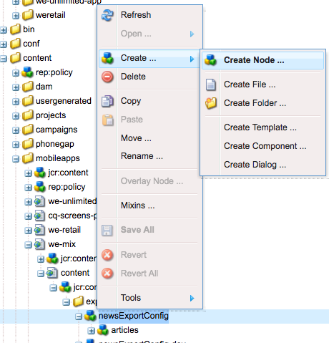

1. Create a node named **articleAssets** of type **nt:unstructured** and click **Ok** to complete.

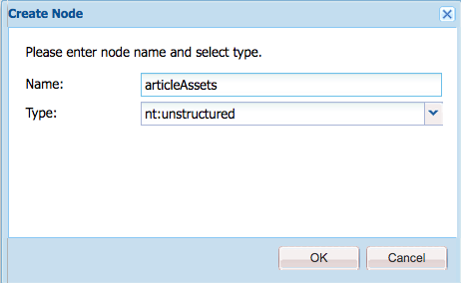

1. Create the following 2 properties by setting the name, type and value then clicking the Add icon  for each.

|  |  |  |
| --- | --- | --- |
| Name | Type | Value |
| type | String | **wemix** |
| path | String | **/content/we-mix/en/news** |

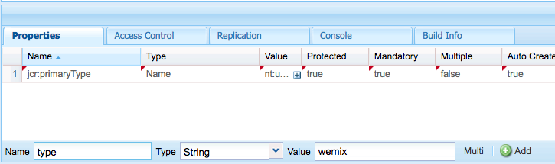

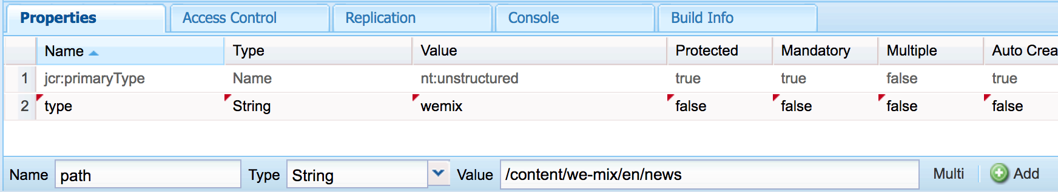

1. Click Save All button from the Action bar found at the top of the page

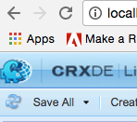  
Note the red unsaved changes indicators have been removed upon save.

### Exercise 3 – Stage and publish another update to include the images

1. In order to view News images in the app, you will need to stage and publish another content update.

To do so, repeat the 9 steps outlined in **Module 3 > Lesson 1 > Exercise 3 (begins on workbook page 16).**

### Exercise 4 – Refresh the app

1. Switch to or relaunch the WeMix Hybird app in the iOS Simulator
2. Click on the News icon in the app tab bar 
3. Pull to refresh  
   Note that images have now arrived!  
   

### Outcome

Congratulations! You have created and configured a new ContentSync export handler to deliver content updates to running apps

# Bonus: Module 4 – Reuse Content Services data for web

This module will demonstrate how you can use Content Services data across your existing web channels.

## Lesson 1 – Content Services component

### Overview

Content Services data is not just for mobile. In fact, its usage is not limited by device type, browser type, or even limited to a specific type of hardware. Due to the lightweight standards-based JSON format, the data endpoints created by Content Services can be consumed by devices that don't even have a screen, such as IoT appliances.

### Objectives

* In this module we will see how a component could be developed to consume AEM Content Services data for use in an AEM Site

### Exercise 1 – Open the We.Mix site for authoring

1. On the AEM Author instance, open the Sites solution from the navigation shade
   1. Shortcut: <http://localhost:4502/sites.html/content>
2. Select the "We.Mix" item to view the pages it contains
3. Select "Welcome to We.Mix", this time tapping the WE.MIX thumbnail image to reveal the actionbar for this page (see top of image):

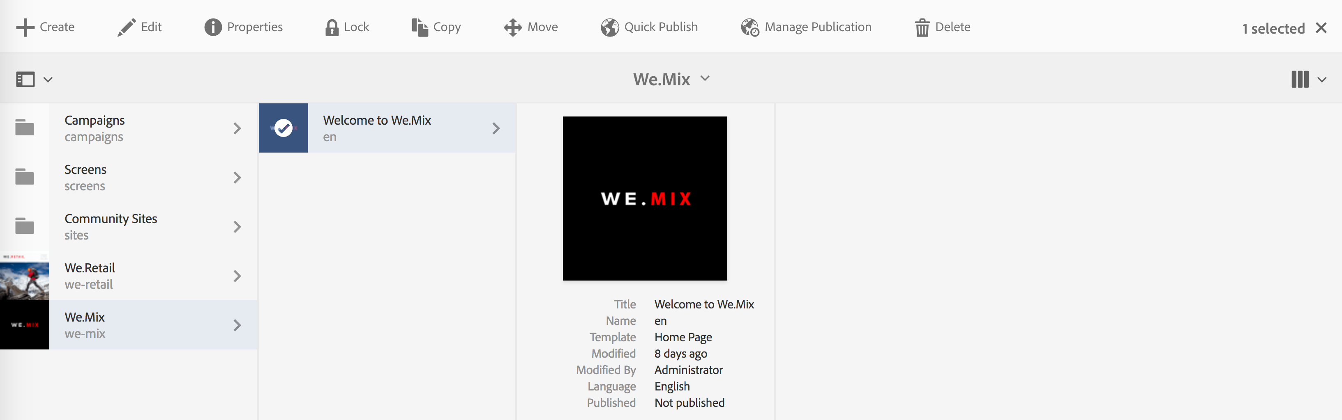

1. From the actionbar, tap the "Edit" item to open the page up for authoring
   1. Shortcut: <http://localhost:4502/editor.html/content/we-mix/en.html>
2. Change modes to "Preview" via the link in the editor's header (towards the right of the page):

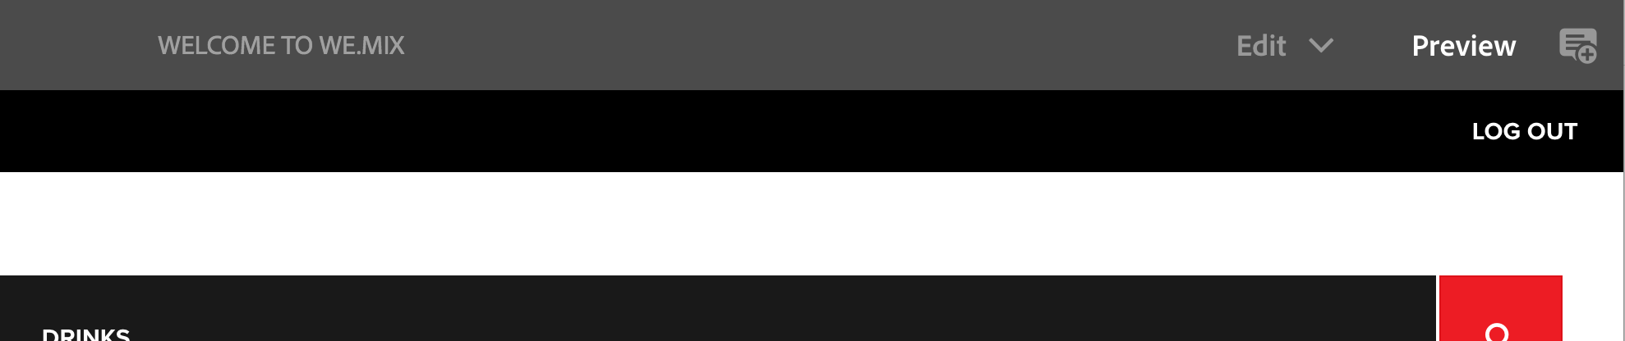

1. Select the "DRINKS" link from the WE.MIX header
   1. Shortcut: <http://localhost:4502/editor.html/content/we-mix/en/drinks.html>
2. Scroll down, until you arrive at a list of 3 drinks
3. Select one of the links, such as Dark n Stormy
4. You will be taken to a page that is primarily empty – this is expected, and is a result of the component not being wired up to a Content Services endpoint yet

### Exercise 2 – Wire up the Drink component to Content Services endpoint

1. In a web browser (such as Chrome), navigate to the CRXDE Lite tool on your author instance: <http://localhost:4502/crx/de/>
2. Using the repository browser on the left pane of the screen, navigate to:

/apps/we-mix/components/content/drinkrecipe/drinkrecipe.jsp

1. Open the file for editing by double clicking the file’s node

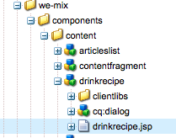

1. To use a property configured in the drinkrecipe component dialog as the source of our Content Services data, include the following line of code in drinkrecipe.jsp at line 41:

|  |
| --- |
| res = resourceResolver.getResource(entityPath); |

1. Save your changes 
2. Refresh the drink page
   1. For example, Dark n Stormy: <http://localhost:4502/editor.html/content/we-mix/en/drinks/drinks/dark-n-stormy.html>
3. You should now see an image of the drink, ingredients, rating, and instructions for mixing it – all coming from Content Services

### Exercise 3 – Create a new Drink page

1. From the AEM 6.3 Sites solution navigate to We.Mix > "Welcome to We.Mix" > Drinks > drinks  
   <http://localhost:4502/sites.html/content/we-mix/en/drinks/drinks>
2. With the "drinks" folder highlighted, tap the blue Create button:

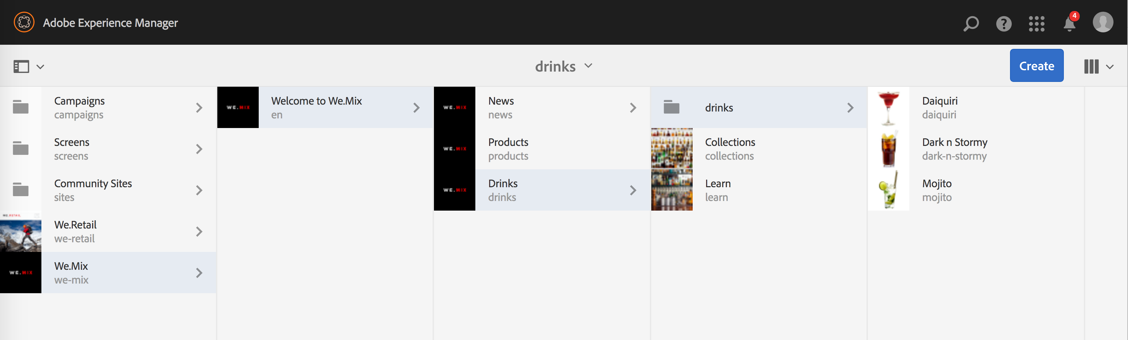

1. From the dropdown which appears below "Create", tap "Page"
2. Select "Drinks Recipe Page" from the list of templates

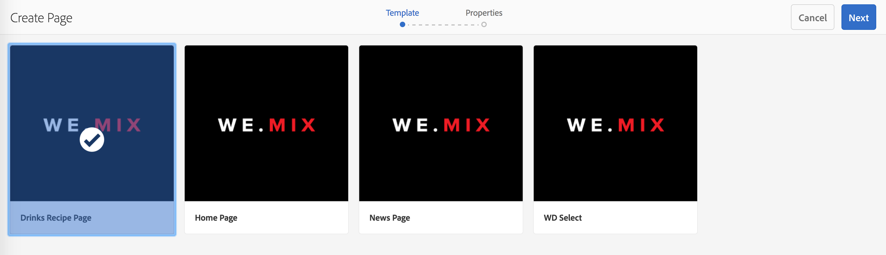

1. Tap the blue "Next" button.
2. Give the page a title of the drink you would like to represent in the We.Mix site, for example "Old Fashioned"
3. Tap the blue "Create" button to create the page
4. From the modal dialog which appears, tap the blue "Open" button
   1. You will be taken to the editor UI, with the new page you just created ready to edit
5. From the editor's header, tap the "Edit" link to switch from Preview to Edit mode 
6. Hover over the empty Rating and Instructions text
   1. A blue outline will appear, indicating that this is the "Drink Recipe" component:

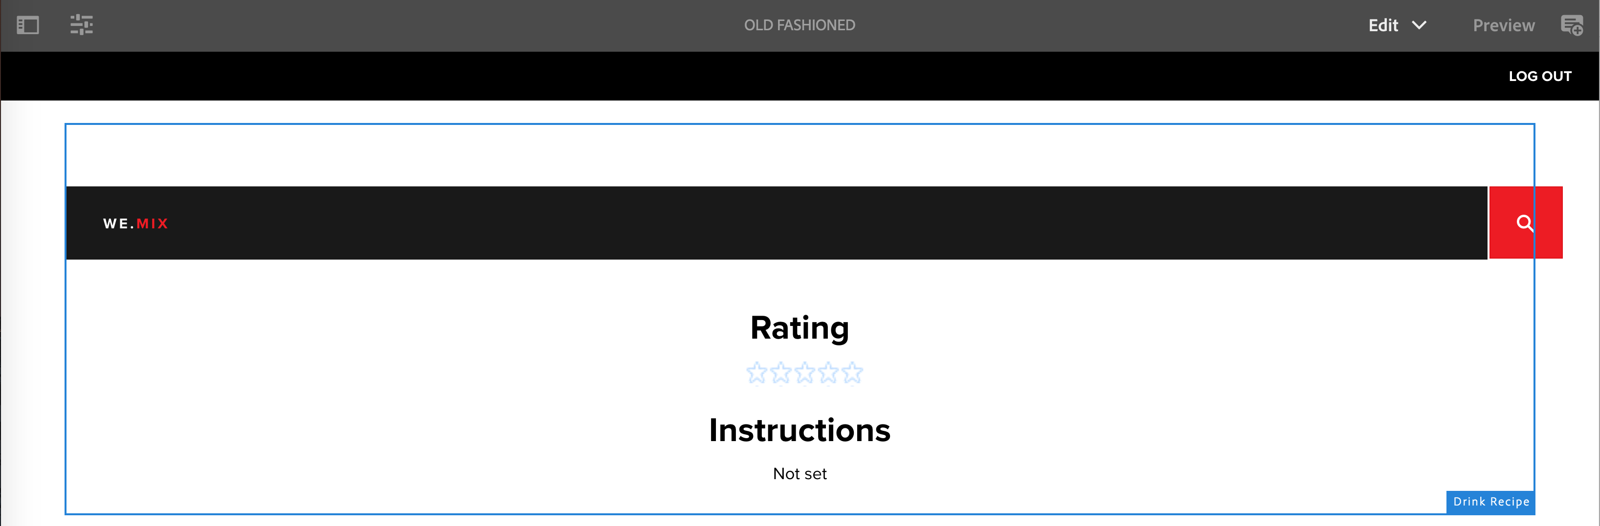

1. Tap within the blue box, then tap the wrench icon on the popup menu which appears

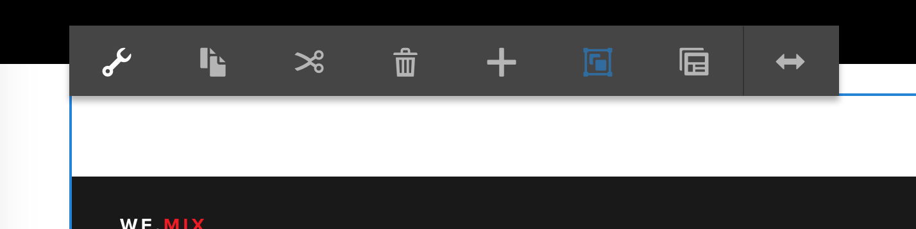

1. In the dialog which appears, configure the Entity path by using the Browse button to browse to the path of the Content Services entity you would like to reuse on this page

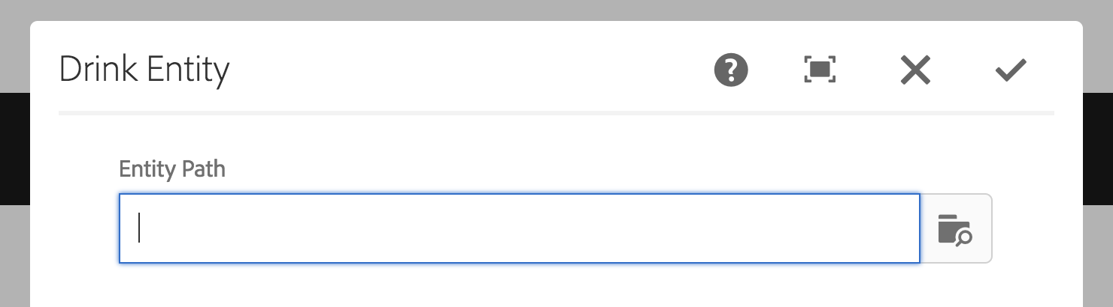

* 1. As a shortcut, simply paste "/content/entities/drinks/recipes/old-fashioned" (no quotes) into the text field

1. Refresh the page – your drink data from Content Services will now be available in the We.Mix page

### Outcome

Congratulations! You have now just reused the Content Services data across both web and mobile channels!

# Bonus: Module 5 – Customize App Dashboard

This module will provide a general introduction to dashboard tiles and dashboard customizations.

## Lesson 1 – Extend the app dashboard with a custom tile

### Overview

Every mobile app has its own set of unique requirements. The AEM Mobile dashboard is a powerful tool that can be leveraged in order to ensure every mobile app can be managed as efficiently as possible.

### Objectives

* Learn about dashboard customization via custom tiles
* Update dashboard to include the custom tile

### Exercise 1 – Create a custom tile

A custom tile has been created and installed for you. See the public github repo and related presentation found at <https://github.com/arumsey/aem-mobile-custom-dashboard>

### Exercise 2 – Configure the WeMix dashboard to include the custom tile

1. Open CRXDE and navigate to the apps jcr:content node at */content/mobileapps/we-mix/jcr:content*  
   <http://localhost:4502/crx/de/index.jsp#/content/mobileapps/we-mix/jcr%3Acontent>
2. Double click the pge-dashboard-config property to trigger the property’s value edit

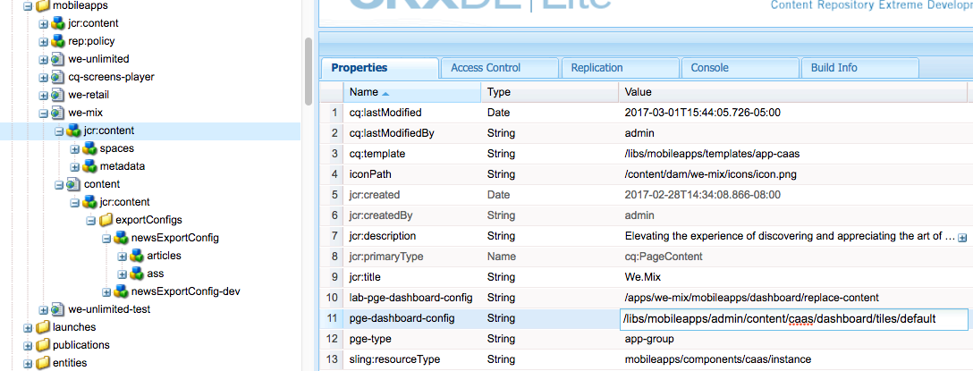

1. Replace the existing path with the new dashboard configuration that includes the new tile.

|  |  |
| --- | --- |
| Replace Value | Replacement Value |
| ~~/libs/mobileapps/admin/content/caas/dashboard/tiles/default~~ | /apps/we-mix/mobileapps/dashboard/replace-content |

You can alternatively copy the value from the extra property lab-pge-dashboard-config (added to facilitate the change)

1. Click Save All icon from the Action bar found at the top of the page

  
Note the red unsaved changes indicators have been removed upon save.

1. Re-open the app dashboard to see the updated dashboard <http://localhost:4502/libs/mobileapps/admin/content/dashboard.html/content/mobileapps/we-mix>

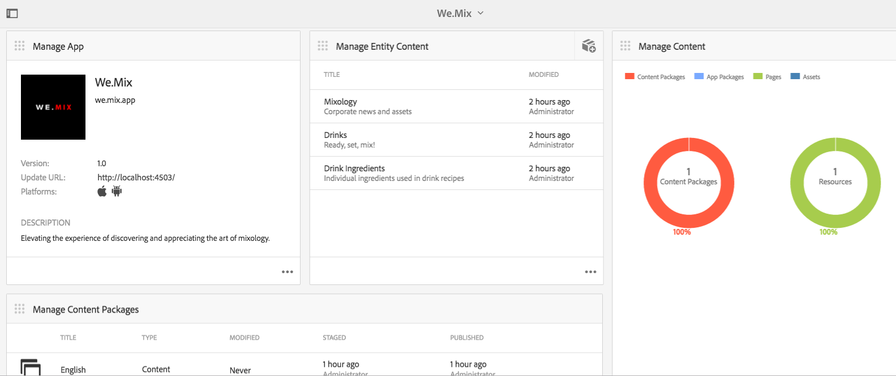

### Outcome

Congratulations! You have customized the We.Mix dashboard to include a custom tile.  
You can customize or remove existing tiles and/or include your own custom tiles to help better report app information or manage app content or workflows.

# Summary

Congratulations! You have just completed the Adobe SUMMIT 2017 lab, "Unleash your mobile app experience with developer customizations". We’ve covered lots of ground:

* + - * Introduction to AEM and the PhoneGap developer toolchain
      * Modeling data in Content Services, and moving that data to a publish instance
      * Wiring up Content Services data to an existing hybrid app
      * Using Content Sync to export AEM content for offline use, and the role of Custom Export Handlers
      * Reusing Content Services data across web channels
      * Extending the AEM Mobile app dashboard with a custom tile

Thanks for joining us today. Enjoy the rest of SUMMIT 2017!